CREATE JAVA APPLICATION

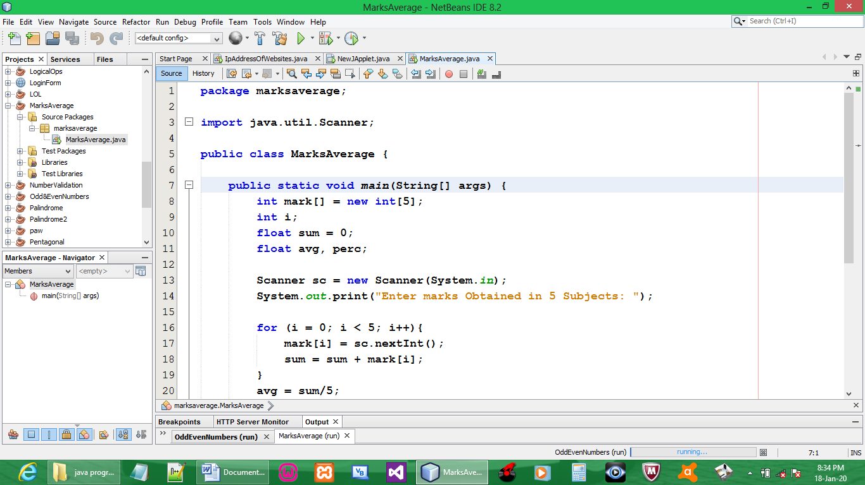

CODE:

package marksaverage;

import java.util.Scanner;

public class MarksAverage {

public static void main(String[] args) {
int mark[] = new int[5];
int i;
float sum = 0;
float avg, perc;

Scanner sc = new Scanner(System.in);
System.out.print("Enter marks Obtained in 5 Subjects: ");

for (i = 0; i < 5; i++){
mark[i] = sc.nextInt();
sum = sum + mark[i];
}
avg = sum/5;
perc = (sum/500)*100;

System.out.print("Average Marks = " + avg);

System.out.print("\nPercentage = " + perc + "% \n");
}
}

OUTPUT:

